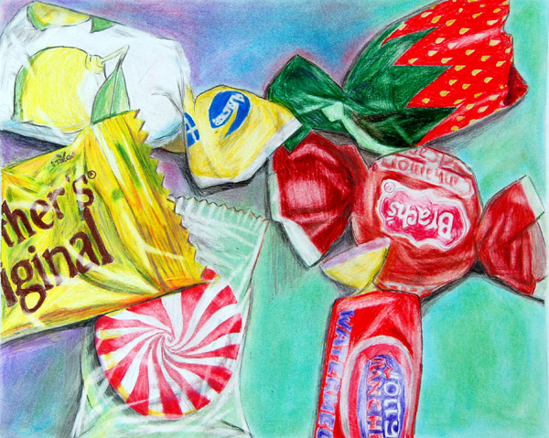

Wayne Thiebaud
Candy
Intro/ 2nd Quarter

Objective
- To create a drawing from observation in the style and color use of Wayne Thiebaud
- To demonstrate an understanding of composition on a smaller scale
- To illustrate an understanding of perspective, values, form and contrast, as well as line
- Experiment with color media and theory to push visualization and interpretation
- Use of at least three candy pieces or more.

Method
- Glue or tape candy down to 5x6 graph with one inch squares
- Sketch contour observation drawing of composition of candy in sketchbook (with confidence in experimentation of ideas to move forward)
- Draw a two inch graph on final 10x12 paper
- Reference sketchbook and observe candy to draw on the 10x12 in color
- Draw and color composition in Thiebaud’s style
Media
- pastel pencils, colored pencils, crayons, copic markers, or any other colored tool. You may also use colored ballpoint pen, micron pens, or other various pens to accent and add contrast to your work.
- No paint used.
- NO use of black used!
- 10x12 or larger white paper. Or colored paper upon request.

Tentative Time Management
- November 28th must start larger paper outside of sketchbook
- December 8th Project due and final critique (Miss. SQ’s last day)
