Color Theory
Review Worksheet

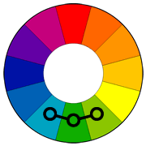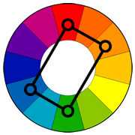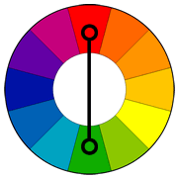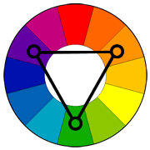
A B C D

1. Which of the above diagrams shows a complementary color harmony? ______________________________________

2. Which of the above diagrams shows the color harmony with the least amount of contrast? _____________________

3. Name the type of color harmony that is shown in Diagram B. ______________________________________________

4. Name two types of light that are outside the visible light spectrum. _________________________________________

__________________________________________________________________________________________________

5. Name two possible colors that could be added to violet to create a shade. ____________________________________

6. Name three secondary colors. _______________________________________________________________________

7. What term describes the relative darkness and lightness of a color? _________________________________________

8. Scientifically, what is white? _________________________________________________________________________

__________________________________________________________________________________________________

9. Name three colors that could be combined to create a triadic color harmony. _________________________________

__________________________________________________________________________________________________

10. Name three colors that would seem to move backward in a design. ________________________________________

__________________________________________________________________________________________________

