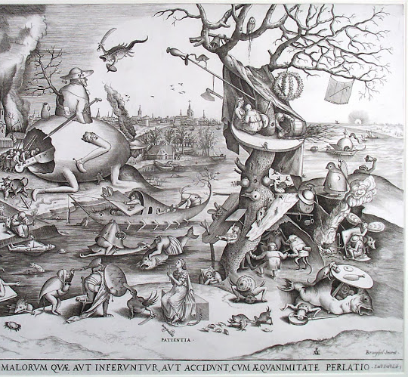
Answer the following questions below to infer about the artwork above. Use the evidence from the visual to justify and explain your answers. Each question is worth 20 points (the last 20 points are bonus!) and a total of 100 points.
- When do you think this artwork was created? Why do you think this? ________________________________________________________________________________________________________________________________________________________________________________________________________________________________________________________________________________________________________________________________________________________________________________________________________________________________________________________________________________________________________________________

- What do you think this artwork is about? What is the artists message? Explain. ________________________________________________________________________________________________________________________________________________________________________________________________________________________________________________________________________________________________________________________________________________________________________________________________________________________________________________________________________________________________________________________
- Why do you think the artist create this artwork? Explain. ________________________________________________________________________________________________________________________________________________________________________________________________________________________________________________________________________________________________________________________________________________________________________________________________________________________________________________________________________________________________________________________
- What do you like or not like about this artwork? Explain. ________________________________________________________________________________________________________________________________________________________________________________________________________________________________________________________________________________________________________________________________________________________________________________________________________________________________________________________________________________________________________________________

