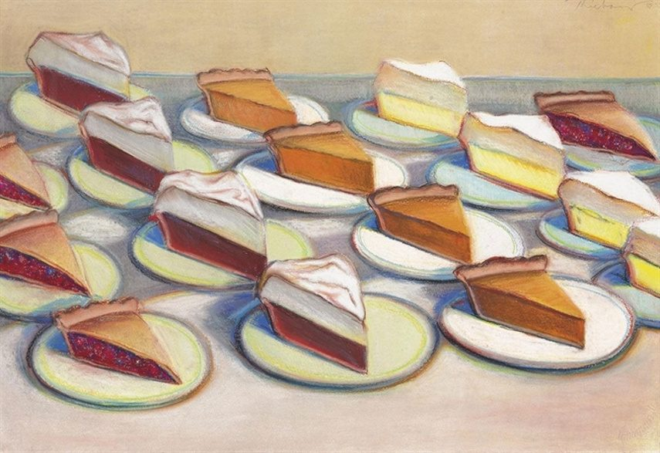

Wayne Thiebaud
Thanksgiving
Drawing/ 2nd Quarter

Objective
- To create a drawing from photo references in the style and color use of Wayne Thiebaud
- To demonstrate an understanding of composition on a larger scale
- To illustrate an understanding of perspective, values, form and contrast, as well as line
- Experiment with color media and theory to push visualization and interpretation
- Use of repetition of a thanksgiving food OR a detailed image of a single food.

Method
- Draw one of Wayne Thiebaud’s pieces in color in sketchbook
- Sketch contour drawing of composition of thanksgiving food in sketchbook (with confidence in experimentation of ideas to move forward)
- Print and reference multiple images of thanksgiving food to construct composition
- Draw and color composition on at least a 16x20 or larger in Thiebaud’s style
Media
- pastel pencils, colored pencils, copic markers, or any other colored tool. You may also use colored ballpoint pen, micron pens, or other various pens to accent and add contrast to your work.
- NO use of black used!
- 16x20 or larger white paper. Or colored paper upon request.

Time Management
- November 13th must start larger paper outside of sketchbook
- November 20th Project due and final critique before thanksgiving break

